**Microsoft Power BI Desktop Installation Guide**

To use Power BI Desktop, you must have **Windows 10** and IE 9 or compatible. As the business intelligence space leader, Microsoft is continuously upgrading Power BI every month. So, do not be surprised if your screen is slightly different from the images in this document.

* Please redirect your browser to <https://powerbi.microsoft.com/en-us/downloads/>.
* Next, please select “Download” under the “Microsoft Power BI Desktop” section.

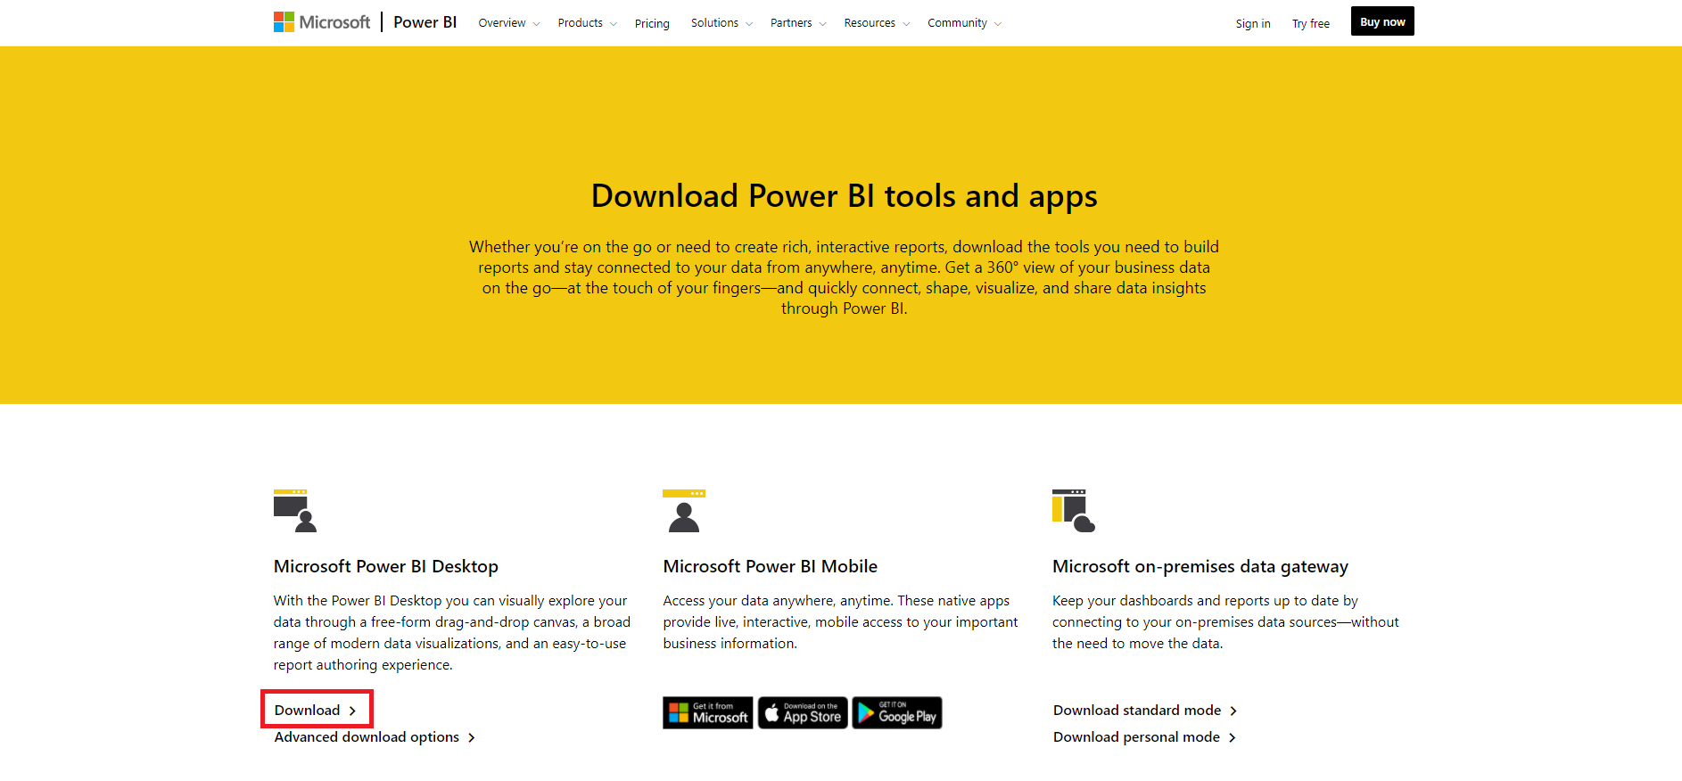

* Afterwards, the Microsoft Store application would pop-up. Select the “Install” button to install the Power BI Desktop locally.

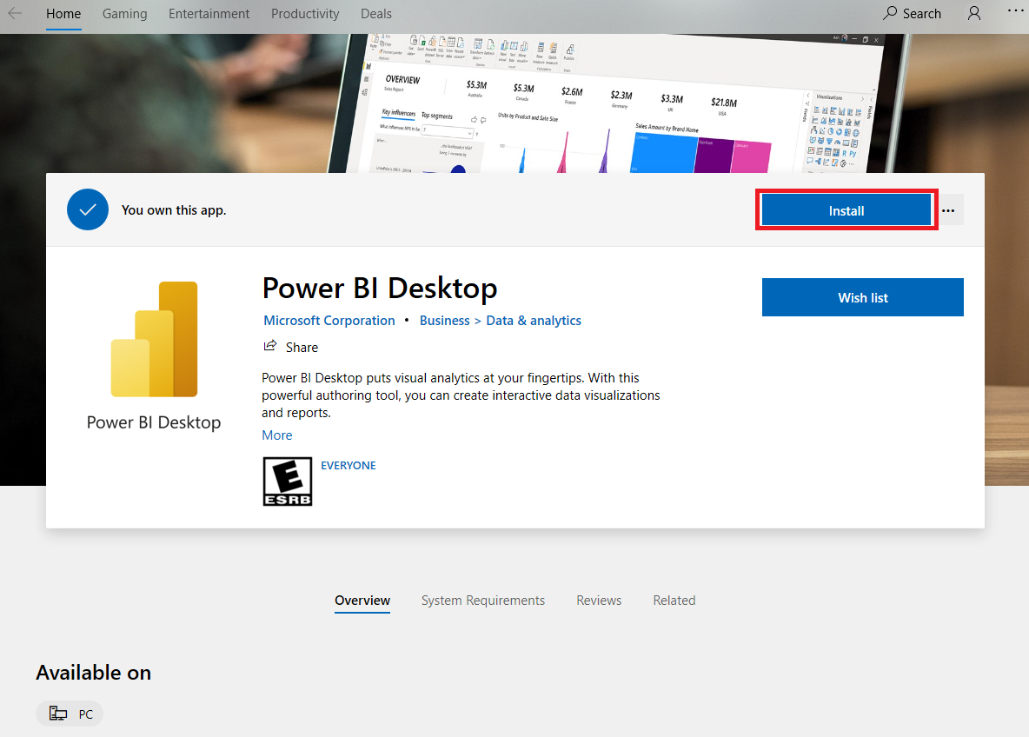

* When the application is finished downloading, please select “Launch”.

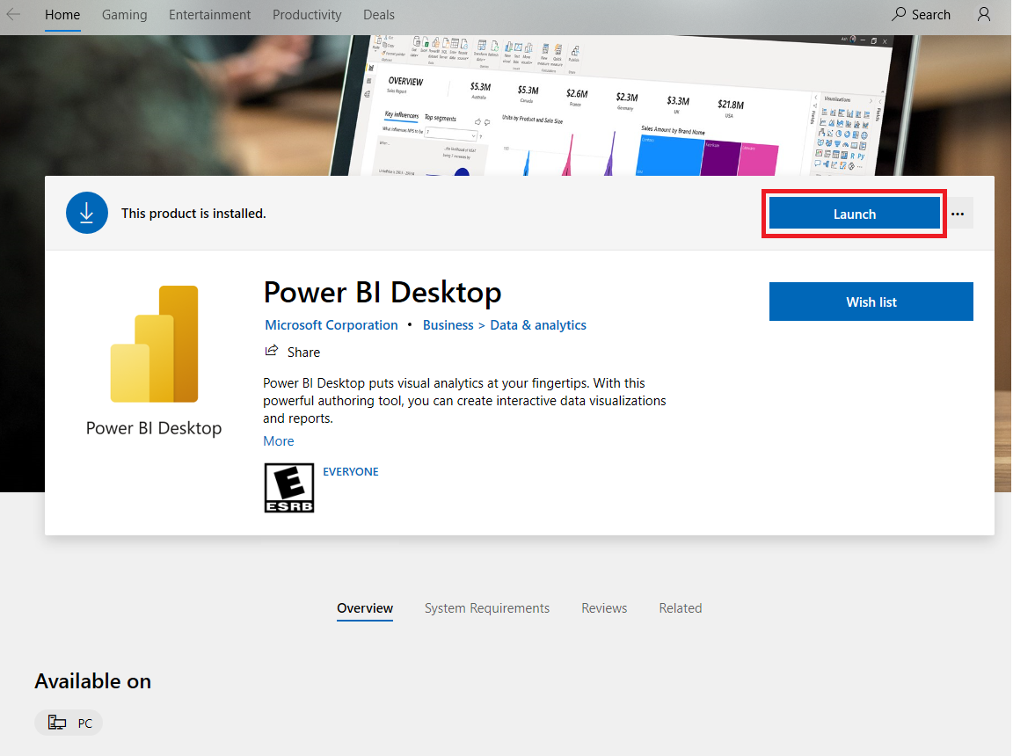

* The picture below resembles what should be seen on screen after the initial download.
* Submit an image similar below. Please capture the date timestamp at the bottom of your screen.

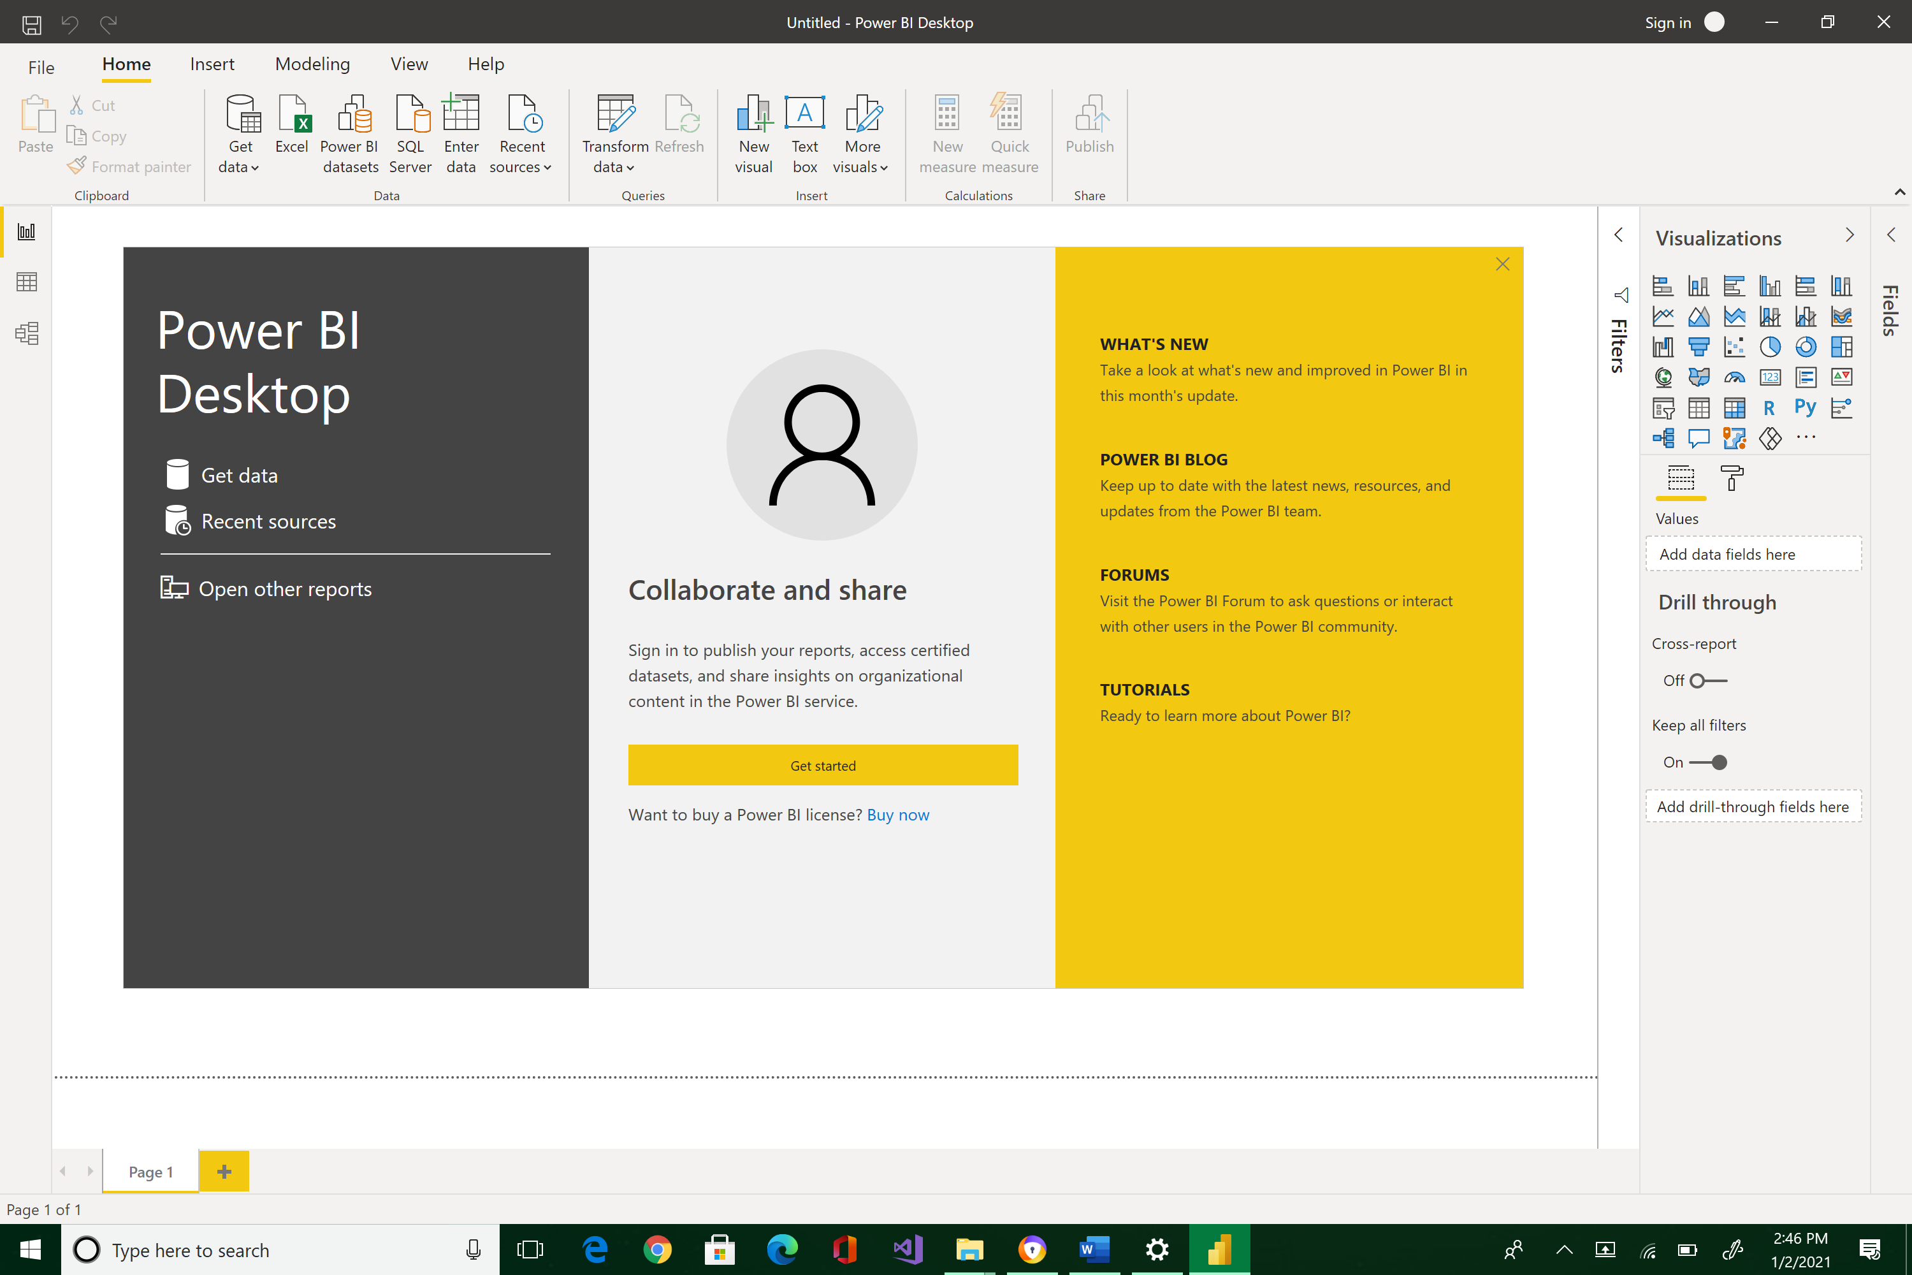



Alternatively, for some reason(s), if you have no Power BI Desktop access at home, log in to NEIT vLabs and complete the exercise using one of the machines in N210, N215, or N110. You do not have to install Power BI Desktop because this is already prepared for you. Just do the last step in this exercise to indicate that you can access this tool.